

**Customer Analytics and Activation**

**Pilot**

**V1.0**

**Prepared By: Dixit Bagadia**

**Date:** 11/26/19

Table of Contents

Table of Contents 2

1. Revision Chart 3

2. Approvers 3

Business Approval 3

Project Team Approval 3

3. Introduction 4

4. In scope 4

5. Out of scope 5

6. Assumptions 5

7. Objective and Success criteria 5

8. Risk 6

10. Timelines 7

11. Data Feeds 7

13. Appendix 9

# Revision Chart

This chart contains a version history of the document’s revision

|  |  |  |  |
| --- | --- | --- | --- |
| **Version** | **Primary Author** | **Description of Change** | **Date Completed** |
| V1.0 | Dixit Bagadia | Document creation | 11/26/2019 |
| V 2.0 | Anurag Satija | Updated doc based on review inputs | 12/5/2019 |
| V3.0 | Anurag Satija | Modifications based on review inputs | 12/10/2019 |
|  |  |  |  |
|  |  |  |  |

# Reviewers / Approvers

## IT / Marketing Reviewers

A summary of the required approvals received for this document are captured below.

|  |  |  |  |
| --- | --- | --- | --- |
| **Approver** | **Role** | **Version Approved** | **Approval Date** |
| Lisa Wegmann |  |  |  |
| Dana Rappe |  |  |  |
| Manish Patel |  |  |  |
| Jason Henkel |  |  |  |
| Andrew Agrimson |  |  |  |
| Eric Bibelnieks |  |  |  |
| Seth Jenkins |  |  |  |
| Christian Snediker-Morscheck |  |  |  |
| Greg Duncan |  |  |  |

## Brand Approval (Premium brands)

A summary of the required approvals received for this document are captured below.

|  |  |  |  |
| --- | --- | --- | --- |
| **Approver** | **Role** | **Version Approved** | **Approval Date** |
| Dan Williams |  |  |  |
| Annie Freer |  |  |  |

## Project Team Approval

A summary of the required approvals received for this document are captured below.

|  |  |  |  |
| --- | --- | --- | --- |
| **Approver** | **Role** | **Version Approved** | **Approval Date** |
| Diane Thorla-Handy |  |  |  |
| D.G. Pike |  |  |  |

# Introduction

This document contains high level details about the pilot project as part of Customer Analytics and Activation (CAA) Program. This pilot project is the initial Proof of concept to test the design of new Cloud Service Platform that can support Advanced Analytics – Data Science Models and can further used to activate and retain customers.

# In scope

| # | Requirements | Deadline | Owner |
| --- | --- | --- | --- |
|  | **Workstream # 5 - Activation** |  |  |
| 1.1 | Pilot project will only include use case PREM SC02 UC10 from the initial list of use cases identified. List of use cases identified attached in the appendix below.  Use case PREM SO2 UC10 - Onboard New purchasers w/ unique track (inclusive of PLUS specific welcome) w/in post purchase email series (goal to drive 2nd purchase in first 60 days) |  |  |
| 1.2 | Leverage existing Email Service Provider (ESP) for Loft, i.e. Cheetah to provide additional features for segmentation using models based on 1st and 2nd purchase history. |  |  |
|  | **Workstream # 4 - Analytics Enablement** |  |  |
| 1.3 | Use data provided to build models to predict user buying behavior for new users based on existing shoppers |  |  |
| 1.4 | Pipeline that delivers customer segments/scoring feed to Cheetah. |  |  |
|  | **Workstream # 3 - Cloud Services Platform with ETL Interfaces** |  |  |
| 1.5 | Create tables that are absolutely required for pilot (mentioned in the data feed section) in cloud environment. |  |  |
| 1.6 | Files feeding data to these tables should have historical. Incremental feeds should be available daily. |  |  |
| 1.7 | Source data required for workstream 4 from CRM for both historical and incremental cadence. |  |  |
| 1.8 | Data will be sourced from Premium CRM (Epsilon) AWS servers. |  |  |
|  | **Security** |  |  |
| 1.9 | Provide logging and monitoring in AWS Cloud. |  |  |
| 1.10 | Ability to manage Identity and Network Access. |  |  |
| 1.11 | Encryption in transit and at rest for our sensitive data. |  |  |
|  | **Documentation** |  |  |
| 1.12 | Written and approved requirements document. |  |  |
| 1.13 | Architectural Review and approval. |  |  |
| 1.14 | Approved Design diagram – Detailed diagram that can be used to build the environment. |  |  |

# Out of scope

| # | Requirements | Owner |
| --- | --- | --- |
| 2.1 | Selection of new Email Personalization Vendor. |  |
| 2.2 | Data for other subject area not mentioned in the attachment for workstream # 3 and 4. |  |
| 2.3 | Other prioritized use cases are out of scope for Pilot |  |
| 2.4 | Upgrade of Premium CRM(Epsilon) servers once migrated to AWS. |  |
| 2.5 | Reporting and campaign results. |  |
| 2.6 | Site personalization (Workstream 5b). |  |
| 2.7 | Pixel data form Ovative. |  |

# Assumptions

* 1. Adequate help from Amazon SME
  2. Ascena will have necessary internal team and staffing required.
  3. Legal discrepancies will be resolved with new platform
  4. Epsilon contract covers the current test plan

# Objective and Success criteria

| # | Criteria | Owner |
| --- | --- | --- |
|  | **Core** |  |
| 3.1 | Dedicated triggered campaigns were executed successfully. |  |
| 3.2 | Local Account Management Team |  |
| 3.3 | Costs and projected growth in costs   * Infrastructure costs in the steady-state reduced by at least XX% percent of the pre-migration costs |  |
| 3.4 | Measured service   * Performance metrics * Steady-state server utilization reduced to XX%* of the pre-migration levels (for now we have kept it arbitrary as team could not define at the time of execution)   *Note: Prior to conducting Pilot, the team could not quantify the server utilization and will be defined once we accomplish the Pilot. |  |
| 3.5 | Application and service availability, overall uptime   * No deterioration in the application availability and performance |  |
| 3.6 | Rapid elasticity |  |
|  | **Workstream # 5** |  |
| 3.7 | Models are available to Cheetah for consumption and creation of emails. |  |
| 3.8 | Testing all tables required as mentioned in Data feed section are available for consumption. |  |
|  | **Workstream # 4** |  |
| 3.9 | Automated batch feed Machine learning pipeline that delivers results to cheetah directly based on developed Model. |  |
| 3.10 | Models were easy to build and data was easy to access in AWS. |  |
| 3.11 | Models are scalable and data points are reaily available. |  |
|  | **Wokrstream # 3** |  |
| 3.12 | Consuming all source tables required for Workstream # 4 for Pilot. |  |
| 3.13 | Received necessary and agreed upon support from Amazon as per the SLA. |  |
| 3.14 | Reduction in batch process times compared to legacy system. |  |
|  | **Security** |  |
| 3.15 | Post implementation control testing – all controls are implemented successfully |  |
| 3.16 | Logs are available in JSonar and Qradar |  |
| 3.17 | AWS is able to provide guidance on this best practices and common points of failures. |  |

# Risk

Epsilon's ability to support incremental data feeds for pilot.

Mitigation plan: Lift and shift to Epsilon AWS. This might introduce a risk for Epsilon to complete the shift within the given time frame.

1. **Architecture diagram**

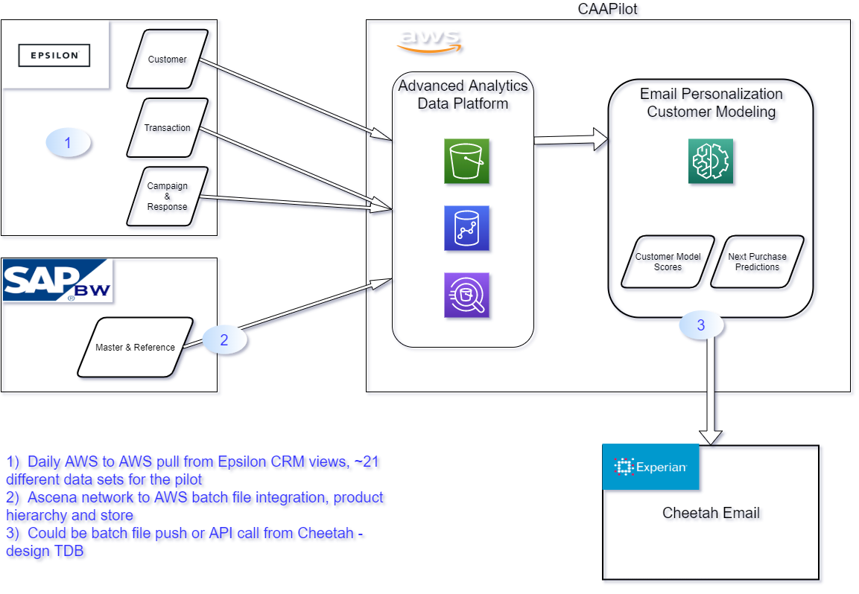

# Timelines

Training/workshops are being conducted in January 2020 for preparation of Pilot execution. Once the Piot and Use Case is validated, a project timeline will be baselined.

# Data Feeds

# Epsilon

|  |  |  |
| --- | --- | --- |
| **Subject Area** | **Table Name** | **Sensitive info** |
| Customer | SUM_INDIVIDUAL | Y |
| Customer Email | F_BRAND_EMAIL | Y |
| Customer Email | LU_CCMP_BRAND_EM_HST | Y |
| Customer Email | F_INDIV_EMAIL_RLTNSHP | Y |
| Customer Email | XREF_INDIV_EMAIL | Y |
| Customer Model Score | F_PFP_SCORE_HIST | Y |
| Customer Model Score | F_NPT_SCORE_HIST | Y |
| Customer Model Score | F_CLV_SCORE_HIST | Y |
| Customer Demographics | LU_DEMOGRAPHIC | Y |
| Customer Merge | XREF_ACCT_INDIV | Y |
| Customer Merge | XREF_INDIV_ORPHAN | Y |
| Customer Merge | XREF_SUM_INDIVIDUAL_HIST | Y |
| Customer Bankcard | SUM_ADS | Y |
| Transaction Header | F_TXN_HEADER_VW | Y |
| Transaction Item Detail | F_TXN_ITEM_VW | Y |
| Transaction Discount | F_TXN_ITEM_DISCOUNT_VW | Y |
| Transaction Tender | F_TXN_TENDER_VW | Y |
| Customer Email | F_CCMP_BRAND_EMAIL | Y |
| Customer Email | F_CCMP_EMAIL_CLICK | Y |
| Customer Email | F_CCMP_EMAIL_SEND | Y |
| Campaign Contact History | LU_CCMP_CAMPAIGN | N |

**SAP Master Data**

|  |  |  |
| --- | --- | --- |
| **Subject Area** | **Table Name** | **Sensitive info** |
| Store | LU_STORE | N |
| Store | LU_STORE_PROMO | N |
| Product | LU_PRODUCT | N |
| Product | LU_STYLE | N |
| Product | LU_PIE_PRODUCT | N |

1. **Detailed Security Requirements**

| # | Requirements | Deadline | Owner |
| --- | --- | --- | --- |
| 4.1 | Logging & Monitoring   * Enable AWS cloud trail. – This is the AWS repository for logs. * Security logs must be shipped to our Qradar instance. * Typical security monitoring – Logins, failed logins, system access, etc. * Data activity monitoring - More granular monitoring/blocking around users accessing data stores. Logs must be fed into JSonar as DAM tool is not compatible with PaaS. * Develop baseline to define normal user activity vs unauthorized behavior. * Develop rules to alert on unwanted behavior. |  |  |
| 4.2 | Identity & Access Management   * Single Sign On using SAML 2.0 * Enable role based access control. * Multi-factor Authentication   + Admins and other privileged users must 2 factor auth always   + End users only have to use 2 factor if they are off network. – This should be an edge case since we are restricting access for users to Ascena VLANs. This might also come into play for 3rd party access to our data. |  |  |
| 4.3 | Network Access Control   * Ascena AWS services must only be accessible from Ascena IP addresses. * Set up firewall rules. * Set up VPN connectivity. * Disable non secure methods of connectivity such as http portals. |  |  |
| 4.4 | Encryption in transit and at rest for our sensitive data |  |  |
| 4.5 | Address common issues with AWS deployments   * Implement AWS best practices. * Leverage AWS security tools where possible to augment normal CSRC processes.   + Monitor exposed services such as S3 buckets for incorrect configurations   + Monitor for unapproved environment changes such as new services, VPC edits, etc. |  |  |

# Appendix

This section provides all attachments mentioned in the requirements.

| # | Attachment | Attached file name |
| --- | --- | --- |
| 1 | Epsilon feeds | [CAA – WS3 – List of potential Epsilon Feeds](https://ascenaretail.sharepoint.com/:x:/r/sites/sp-asc-CustomerAnalyticsActivationCEMReset/Shared%20Documents/2.%20%20Planning/Pilot%20Use%20case/CAA%20-%20WS3%20-%20List%20of%20Potential%20Epsilon%20Feeds.xlsx?d=w416a503673ce4cd69feefa460bc47777&csf=1&e=pfPvGi) |
| 2 | New Client onboarding use case document | [New Client Onboarding Brief](https://ascenaretail.sharepoint.com/:w:/r/sites/sp-asc-CustomerAnalyticsActivationCEMReset/Shared%20Documents/2.%20%20Planning/Pilot%20Use%20case/New%20Client%20Onboarding%20Brief.docx?d=w3cb4d48d40c149b5bdd0855ccf393738&csf=1&e=34VSBo) |